**CHAPTER 1**

**Introduction**

**1.1 Background:**

The Online Quiz is a web application for candidate to appear for an online test in an effective way and there is no loss of time to check the paper. The chief aim of Online Quiz is to effectively estimate the candidate completely via a totally automated system which besides preserving time, offers swifter outcomes. Generally, pupil are provided with paper, pen etc for taking the test but the Online Quiz doesn’t require all these. Online Quizzes are a popular form of entertainment for web surfers. Online quizzes are generally free to play and for entertainment purposes only though some online quiz websites offer prizes. Websites feature online quizzes on many subjects.

The online quiz is a web application for to take online test in an efficient manner and no time wasting for checking the paper. The main objective of online quiz is to efficiently evaluate the candidate thoroughly through a fully automated system that not only saves lot of time but also gives fast results. For students they give papers according to their convenience and time and there is no need of using extra thing like paper, pen etc. this van be used in educational institutions as well as in corporate world. Can be used any time as it is a web based system.

**1.2 Motivation:**

To do something that would be of use to the society is always the part of our dream. As there were many projects that can be done with the help of HTML, CSS, PHP, MySQL, so development of Online quiz seemed to be an excellent idea. Online Quiz can save the time, and effort. This system ensures entertainment, fun for the players. Also, we can utilize our spare time by playing this game. The advantage of this software is that it is free as well as costless.

**1.3 Problem Statement:**

**1. Filing poses a problem:**

Filing the documents categorically is a time consuming and tedious exercise.

**2. Lack of space:**

It becomes a problem to find space to keep the sheets of paper being generated as a result of the ongoing discussion. The documents being generated are too important to be ill-treated.

**3. Filtering is not easy:**

It becomes hard to filter relevant documents for the irrelevant ones if the count of the same crosses a certain manageable number.

**4.Reviewing becomes time-consuming**:

All the process done manually at the centers and all the records are maintained on the papers. So the maintenance of the record is very difficult in the departments and as well as it’s very difficult for the workers to check the record. The Existing system is paper based, time consuming, monotonous, less flexible and provides a very hectic working schedule. The chance of loss of records is high and record searching is difficult. Maintenance of the system is also very difficult and takes lot of time.

**1.4 Objectives:**

The main objective of the Online quiz system is to efficiently evaluate the candidate through a fully automated system that saves a lot of time and also gives fast results.

**1.5 Scope:**

Online Quiz System is designed for Educational Institutes like Schools, Colleges, and Private Institutes to conduct logic tests of their students on a regular basis. Both educational organizations and corporate companies can employ this quiz. It, being an application based on web may be taken at any place or any time as the location is not considered. The system handles all the operations and generates reports as soon as the test is completed which saves the precious time of faculties spent on reviewing answer sheets. The presence of the examiner is not required while the candidate is appearing the test. The existing system is weak when it comes to surprise test organizations whereas this system can make it possible very easily.

**CHAPTER 2**

**Literature Review**

**zf**

**2.1 Existing System:**

**2.1.1 Quipoquiz.com**

Quipoquiz is a true or false quiz games. There are many categories such as animals, arts and cultures, geography, history, science and technologies, sports and each categories have sub categories. The user selects the sub categories in which s/he wants to play quiz on. The user is then asked a question and s/he has to choose only one option i.e. either true or false. Each question carry 1 point and user can select the quiz length i.e. 10, 15 or 25 questions. Questions are displayed randomly so that user can discover new information every time they play. [3]

**2.1.2 Yourbrainmatters.org.au/quiz**

Your Brain Matters Quiz is a medium to find out how much you know about various subject matters like music knowledge, general knowledge, geography, sports, your amazing body, your amazing brain, etc. On clicking on a subject matter, the user can start quiz. After starting the quiz, a timer starts and 10 multiple choice questions are displayed one at a time until user press a ‘next’ button to display next question. Each subject has a 10 minutes duration. [4]

**2.2 Proposed System:**

The Online Quiz System is a web-based application. It will reduce the large amount of paper works required in the manual methods, and possibly accurate result with minimum error will increase. The users and the institutes can easily get any of the information just within a single click. Our proposed system will also save the time consumption of both the students and the authorities conducting the quiz. Result will be very precise and accurate and will be declared in very short span of time because calculation and evaluations are done by the simulator itself. The proposed system is very secure as no chance of leakage of questions cause it is dependent on the administrator only.

Our proposed system is an Quiz based website which have 2 modules one is candidate(user) and second is administrator. Administrator has the privilege to login, mange subjects, can upload and make questions, create events for the candidates and logout. The candidate has to register before they can start the quiz. He/she has to login, select subject and take test for the chosen subject. He/she can also view the score obtained from the test given.

**CHAPTER 3**

**METHODOLOGY**

**3.1 Overview:**

This section focuses on the various basic methodologies for the proposed system. The main goal is to implement a proposed system that will be used to provide a user-friendly interface through which student can appear Quiz online.

**3.2 Block Diagram:**

Online Quiz System

User

Admin

Login

Login

Quiz Subjects

Manage Subjects

Profile

Manage Questions

Users

About

Logout

Logout

Fig 3.2.1: Block Diagram of Online Examination System

**3.3 Tools and Platform: -**

In Online Quiz System we use: -

* 1. **Software Technology:**
* Operating System – Windows-XP, Windows Vista, Windows 7 or higher
* Web Server – Apache Server
* Web Browser – Internet Explorer, Chrome, etc.
* Database – MySQL

**CHAPTER 4**

**RESULTS AND DISCUSSION**

**4.1 Result:**

**1) Admin Panel:**

**a) Login**

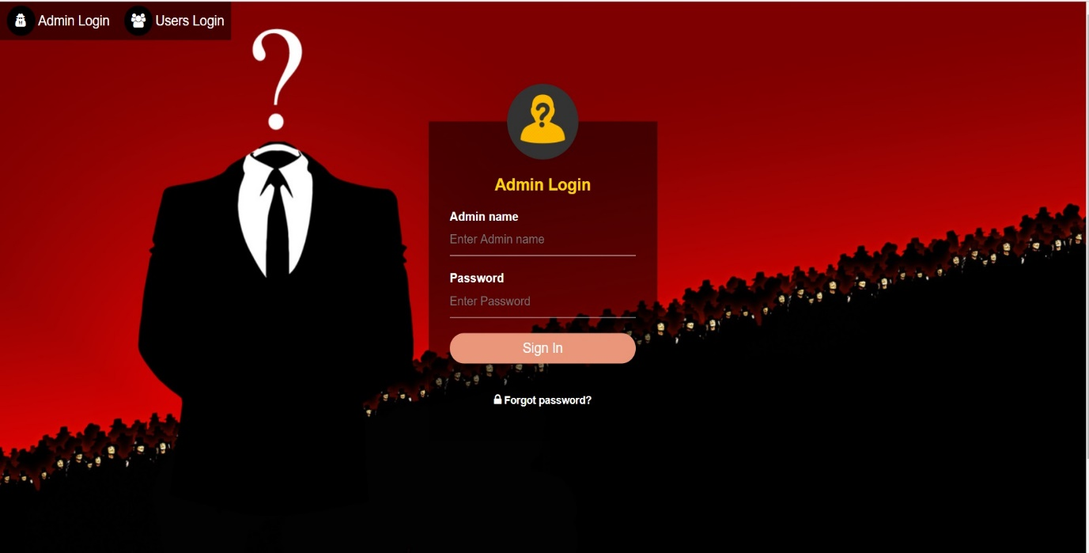

Figure (4.1.1): Admin Login Page

**b) Home**

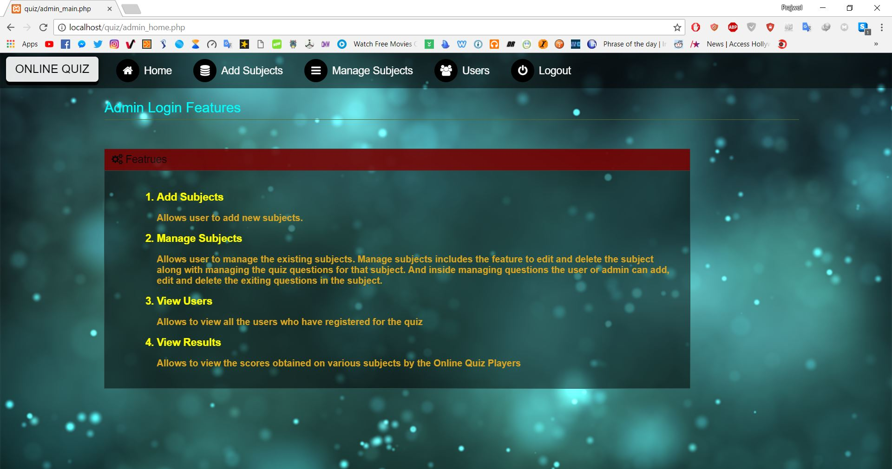

Figure (4.1.2): Admin Home Page

**c) Add Subjects**

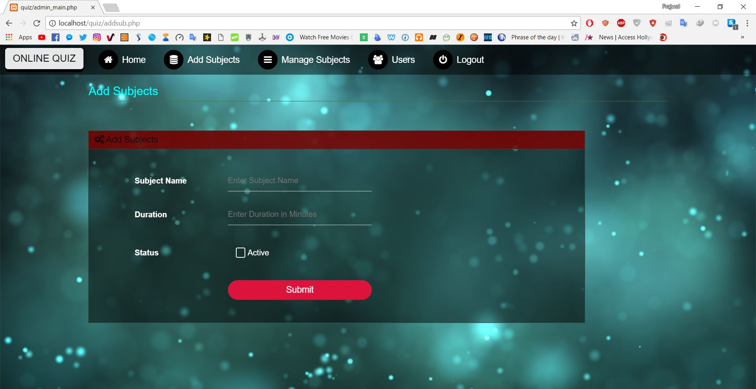

Figure (4.1.3): Add Subjects

**d)Manage Subjects**

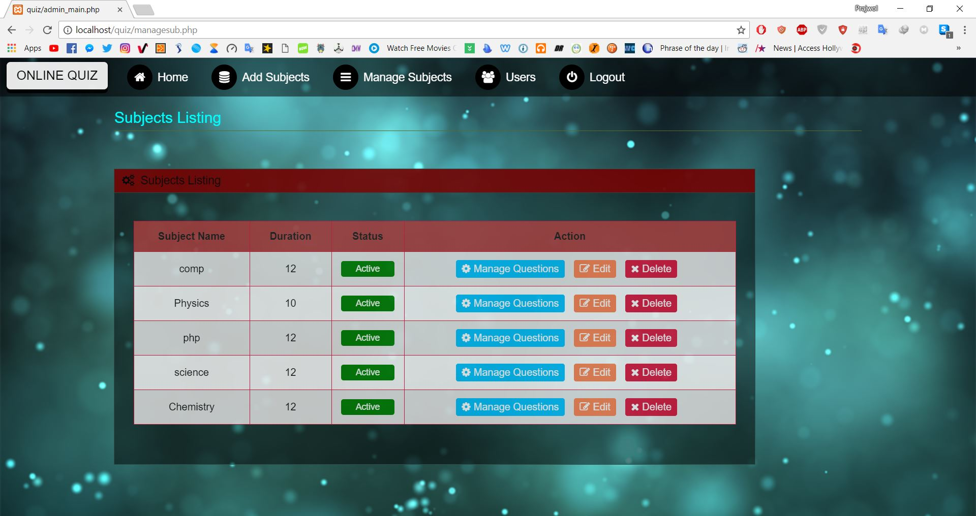

Figure (4.1.4): Manage Subjects

**2) User Panel**

**a)User Login**

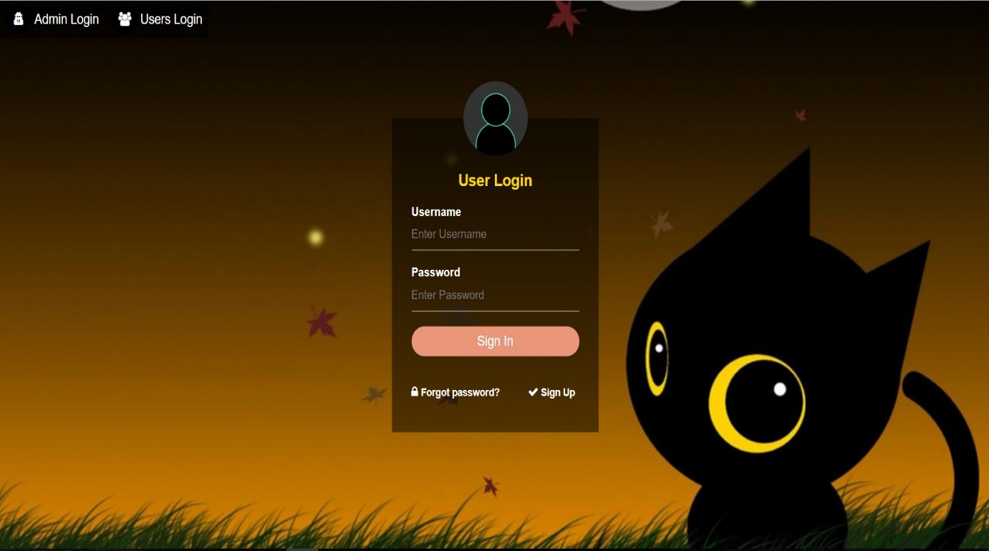

Figure (4.1.5): User Login

**b) User Sign Up**

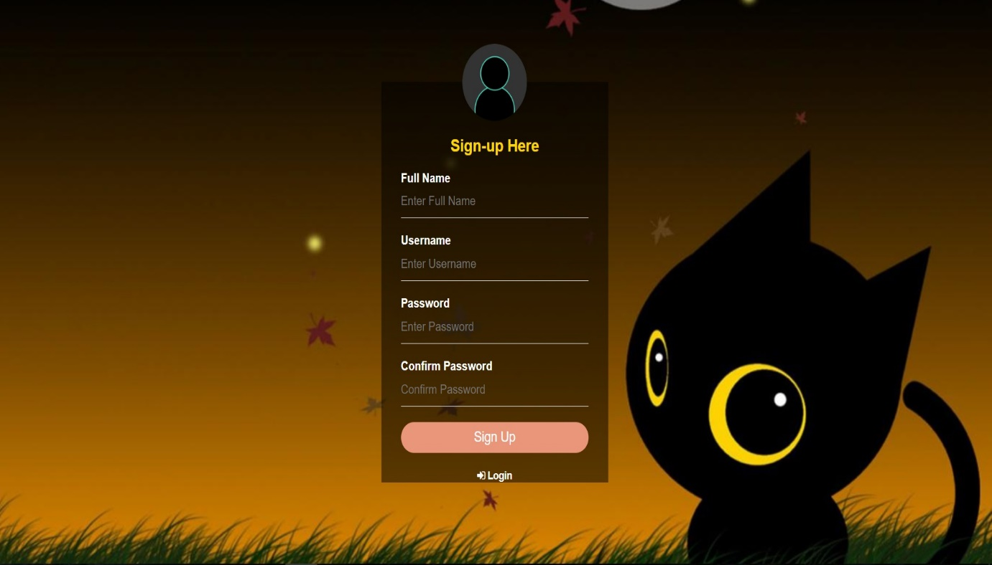

Figure (4.1.6): User Sign Up

**c)User Home Page**



Figure (4.1.7): User Home Page

**d) Quiz Subjects**

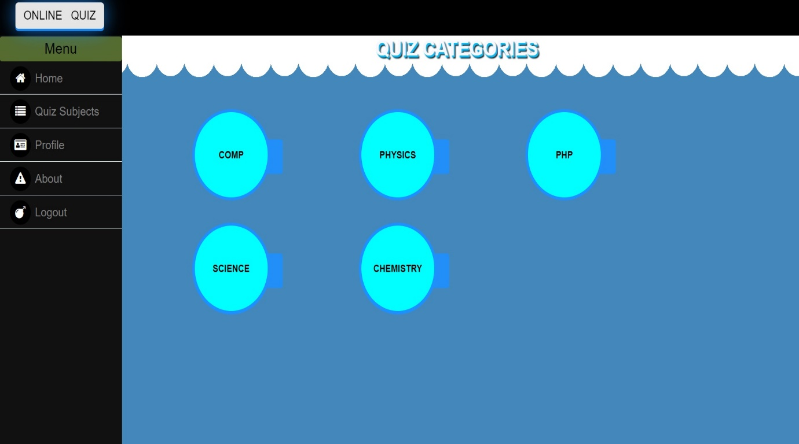

Figure (4.1.8): Quiz Subjects

**d) Profile**

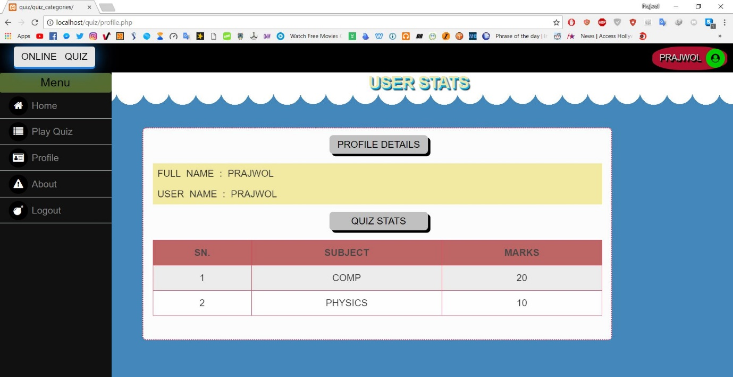

Figure (4.1.9): Profile

**d) About**

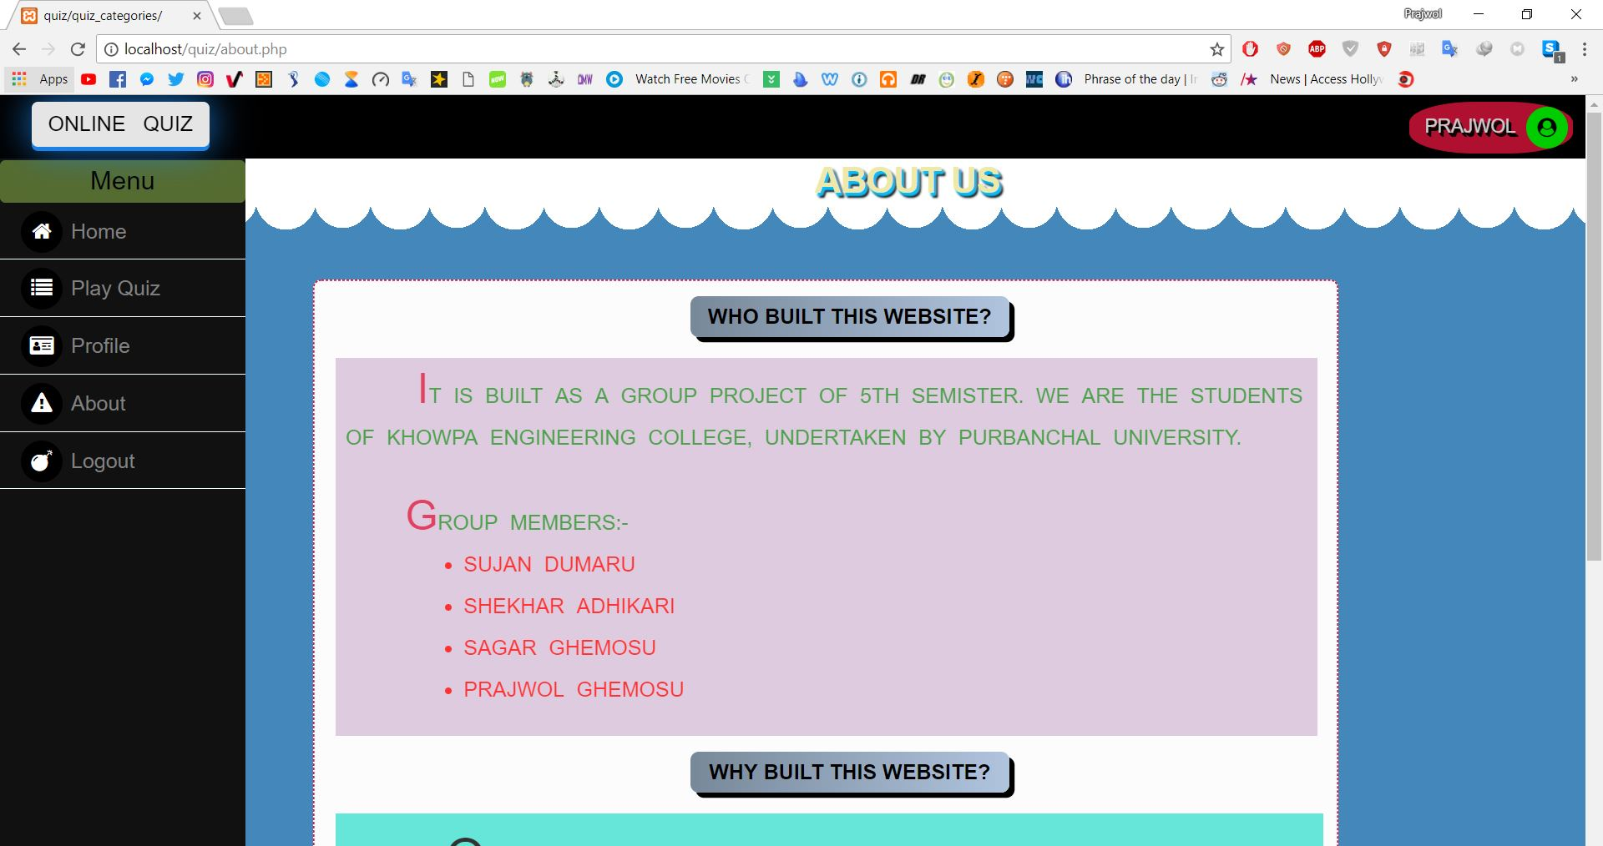

Figure (4.1.10): About

**4.2 Tasks Accomplished:**

The tasks accomplished in this project are

1. Function to add and manage subjects in admin section
2. Function to add and manage questions in admin panel
3. Function to play quiz game
4. Function to view user score
5. Function to view user profile

**CHAPTER 5**

**CONCLUSION AND RECOMMENDATION**

**5.1 Conclusion:**

We developed an ONLINE QUIZ system. This system required the function of adding subjects, managing subjects, adding questions, managing questions, displaying the number of questions to users in the quiz game, viewing the score of the players as well as user information. Therefore, keeping these functions in mind, we have developed simple Online Quiz.

**5.2 Future Recommendation:**

There can be made many improvements in the system we developed. Some of the future recommendation to make the system qualitative are:

* Make the system more responsive.
* Add the timer in the system.
* Increase login security to secure the information.
* Make the system more user friendly.

**REFERENCE**

1.“Online Quiz System Video”, https://www.youtube.com/watch?v=AOkvMF7ul74 [Visited date: - 2017-12-17]

2.“Quiz Game”, https://www.quiz.com [Visited date: - 2017-12-17]

3. “Quipoquiz”, https://www.quipoquiz.com [Visited date: - 2017-12-18]

4. “Your Brain Matters”,https://www.yourbrainmatters.org.au/quiz [Visited date: - 2017-12-18]